The Bobcat: A formidable predator under threat
The bobcat is a powerful and highly efficient predator. It is being threatened by the senseless killing for its fur......
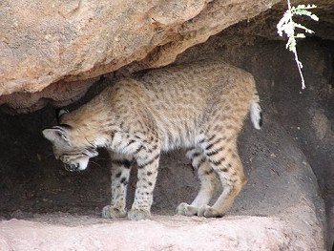
The bobcat can be found in Canada, North America and Mexico. Its diversity of habitats include forests, mountains, swamps, and deserts. Its excellent eyesight, sensitive ears, sharp and powerful teeth and claws make it an efficient predator. In common with the Antelope Jackrabbit, it keeps absolutely still if approached by humans, relying on camouflage to escape detection
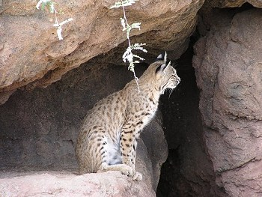
These photographs were taken in the Arizona-Sonoran Desert Museum, near Tucson, Arizona. In this location it can be protected from trappers and other threats to its natural habitat.
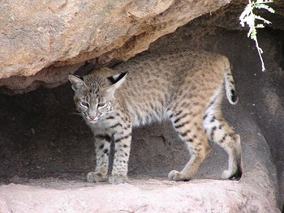
In common with other animals in the USA it had been killed in large numbers before 1970, because it had been associated with a threat to livestock, including lambs and poultry. However, its main diet consists of rabbits, mice, small squirrels, gophers and wood rats. It captures its prey by using stealth, rather than speed of pursuit.
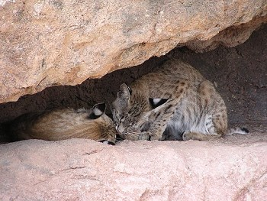
The bobcat is still killed for its fur, mainly as a result of a shift from the killing of large cats which are now protected internationally. This hunting still continues, even though there are restrictions on the length of a hunting season. Fortunately, the bobcat has survived the trappers mainly as a result of its location in virtually inaccessible places for during the winter months, when hunting is permitted.

All Images : © Martyn Overy www.mywebschool.org/postnuke

